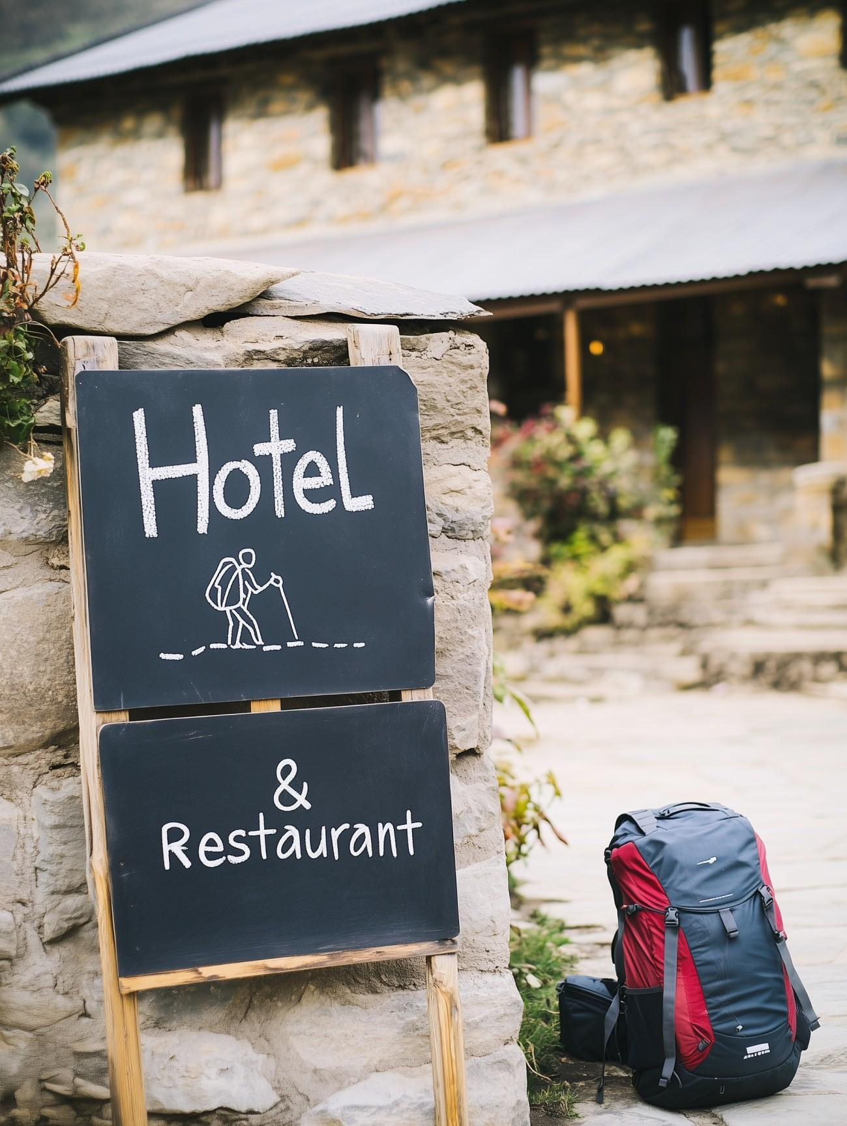

FAQ Call for financial support

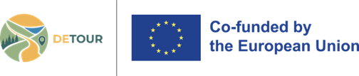
Funded by the European Union. Views and opinions expressed are however those of the authors only and do not necessarily reflect those of the European Union or EISMEA. Neither the European Union nor the granting authority can be held responsible for them.

Image Credits: MidJourney AI prompt by Aleksandra Fomina

Single Market Programme (SMP COSME)

SMP-COSME-2023-TOURSME
Transitioning to a more sustainable and resilient ecosystem – empowering tourism SMEs

Name of the Project: | Development of resilient tourism ecosystems along Mediterranean walking routes
Acronym: | DETOUR
Proposal Number: | 101181295
Project Duration and start date: | 36 months, 01 November 2024
Lead partner/coordinator: | Comune di Fidenza (Italy)
Partners: | Kultur Rotalari Dernegi, DMO ES.CO. Esquilino Comunita – La Porta Di Roma, Antalya Il Kultur Ve Turizm Müdürlüğü, Training 2000 Piccola Sc, Mesogeiako Kentro Perivallontos, Organizatsia Za Upravlenie Na Trakiyski Turisticheski Rayon, Associazione Europea Delle Vie Francigene
Email: | detour@comune.fidenza.pr.it
Website: | www.detour-eu-project.eu

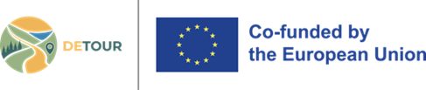

DETOUR: Developing Resilient Tourism Ecosystems along Mediterranean Routes
FAQ SMEs

- How do I apply to the call?
Submit your candidature via this form (LINK), providing details on your business and completed application templates, available for download at LINK
- Where can I find more information about the call?
Consult the pages of the call for SMEs operating in Italy, Bulgaria, Türkiye and Greece. LINKs
- Can I participate if I am not from the tourism sector?
Yes. The programme is also open to cross-sector SMEs: accommodation services, camping grounds, food and beverages, agritourism and ecotourism locations, farms, national parks, restaurants and beverage services, mobility and transport services within cities and rural tourism destinations, tour operators, agencies, and related tourism management services, creative, arts, and entertainment activities, libraries, archives, museums, and other cultural activities, sports activities, amusement, and recreational activities, IT or Energy solutions for the tourism sector, environmental and circular economy services related to tourism.
- What language should the application be written in?
The applications must be submitted in one of the project languages: English, Italian, Greek, Bulgarian, Turkish.
- Can one of the project partners be registered in a foreign country?
Yes. One of the partners may be registered in another country, provided it is located within one of the project’s countries: Greece, Bulgaria, Italy, or Turkiye, located / operating along the selected walking routes or in their buffer zones.

- What counts as “operating along the walking route”?

SMEs may be either located within the designated pilot areas of the walking routes in each project country, or legally registered elsewhere in one of the eligible countries, provided they actively operate on one of those routes. This may include, for example, a tour operator registered outside the selected area but delivering services along a project walking route.

- Can SMEs that did not participate in the DETOUR SME training still apply to the call and form partnerships?

Yes. Participation in the DETOUR SME training is not a precondition for applying to the call or for forming a partnership. SMEs that did not take part in the training are still fully eligible to participate, provided they meet the other eligibility requirements of the call.
However, during the evaluation, Consortia will receive 1 additional point if at least one applicant has participated in the DETOUR SME training programme.

- Can members of the same family apply separately with their SMEs?

Members of the same family cannot apply together for a project, even if they own two separate SMEs.

- Can two businesses owned by the same person or two different persons from the same family apply as partners within the same project?
No. If both businesses are owned by the same person or persons from the same family, they cannot participate as partners in the same project, as this would constitute a conflict of interest.

- Can the same applicant submit more than one project proposal?

No. Each candidate may submit only one project proposal.
If a candidate submits more than one project, only their last one will be taken into consideration, and they will be disqualified automatically from the other applications, which will then be assessed (eligibility and evaluation) without their inclusion (so if 4 apply for a project, the application will be assessed on the basis of three partners, and it would not be possible to substitute the 4th at that stage).

- How is the grant amount between €15,000 and €25,000 decided?
Applicants decide on the amount of the grant they would like to obtain (at least €15,000 and no more than €25,000) in the application. The requested amount should be justified through the proposed activities and budget template. The SMEs are suggested to request an amount that is realistic, clearly linked to the work plan, and well justified in the budget.

- What does “lump sum funding” mean in practice?

The grant is awarded as a lump sum, with 100% funding and no co-financing required. Payments are made in three instalments: 20% at signature, 40% mid-project after the interim report, and 40% after the final report. The SMEs are suggested to manage the project carefully, keep financial records, and be ready to prove both implementation and results.

- How demanding is the reporting for a small grant?

Selected projects must provide:
- progress reports every 3 months
- an interim report to receive the second instalment

- How “collaborative” does the project need to be?

A simple individual investment is unlikely to be competitive. The proposal should show real cooperation, clear partner roles, and benefits beyond one company.

- Can the partnership hire subcontractors or external service providers?

Yes, the call allows eligible costs for consultancy services, external experts, mentors, consultants, technicians, market studies, audits, training, certification support, and similar services essential for the project.

- Can existing employees’ working time be covered by the grant?

Yes. The call explicitly lists working time of employees focused on the project as an allowable cost. It also requires all costs to be necessary, identifiable, verifiable, and compliant with accounting principles, and asks beneficiaries to keep supporting documentation.

- What happens after I submit my application to the call?
- You will receive an acknowledgement confirming that the Consortium has received your application.
- Your application will be evaluated by a selection committee between 1 June and 12 July 2026.
- The results will be published on the official project website by 13 July 2026.
- If your project is selected, the Consortium will ask you to provide a Partnership Agreement and sign a Grant Agreement with the Consortium.
- Selected projects are expected to start on 1 September 2026.

